
School: ............................................................................................................. Campus: ....................................................... Academic Year: ...................... Subject Name: ........................................................... Subject Code: ..........................
Semester: ............... Program: ........................................ Branch: ......................... Specialization: .......................... Date: .....................................
(Learning by Doing and Discovery)
* Coding Phase: Pseudo Code / Flow Chart / Algorithm
Introduction to Blockchain
Blockchain is a peer-to-peer, distributed ledger that is cryptographically secure, append-only, immutable (extremely hard to change), and updateable only via consensus or agreement among peers.

FEATURES OF BLOCKCHAIN:
- Decentralized
- Immutability
- Transparency
- Smart Contracts
- Security
- Consensus Mechanisms
- Distributed Ledger
- Anonymity and Privacy
Blockchain Architecture Design
The architecture comprises several key components:
- Nodes: Individual computers or devices that participate in the blockchain network.
- Blocks: Transactions are grouped into blocks and added to the blockchain sequentially and immutably.
- Consensus Mechanism: A protocol or algorithm used by nodes to agree on transaction validity and blockchain state.
  - Common mechanisms are:
    - Proof of Work (PoW)
    - Proof of Stake (PoS)
- Smart Contracts
  - Self-executing contracts with predefined rules encoded into the blockchain.
  - Automatically enforce and execute agreements when conditions are met, eliminating intermediaries.
- Cryptographic Security
  - Uses techniques like hashing and digital signatures to secure data.
  - Ensures transactions are tamper-proof and transparent.
- Network and Protocols
  - Blockchain networks operate using specific protocols for node communication and transaction validation.

Coding Phase: Pseudo Code / Flow Chart / Algorithm
Create the First Block (Genesis Block):

Define the data:

For the genesis block, you'll typically include some initial data, like a message or a starting transaction.

Create the block header:

Populate the header with relevant information. Since it's the first block, the "previous block hash" will be empty or a predefined value.

Hash the block:

Apply a cryptographic hash function (like SHA-256) to the entire block (header and data).

Link the blocks:

The hash of the current block becomes the "previous block hash" in the header of the next block to be added to the chain.

Continue adding blocks:
Repeat the process of creating blocks, hashing them, and linking them together to build the blockchain.

https://andersbrownworth.com/blockchain/
https://blockchaindemo.io/

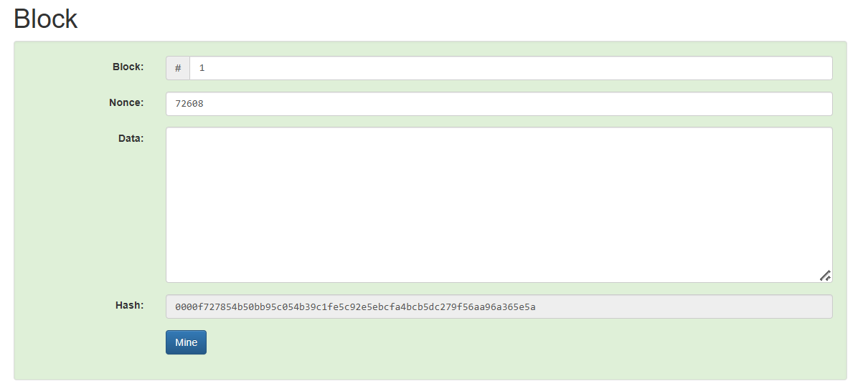

* Softwares used
- Brave Browser

- Testing Phase: Compilation of Code (error detection)

Phase: No data Modification
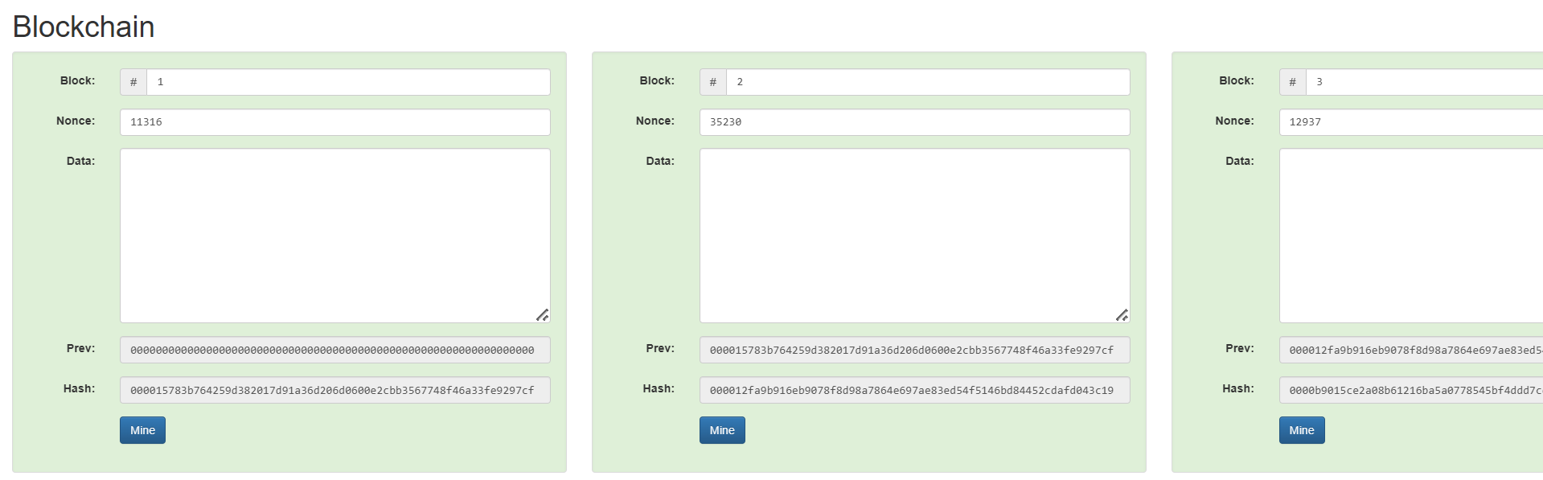

Phase: Data inserted in one block
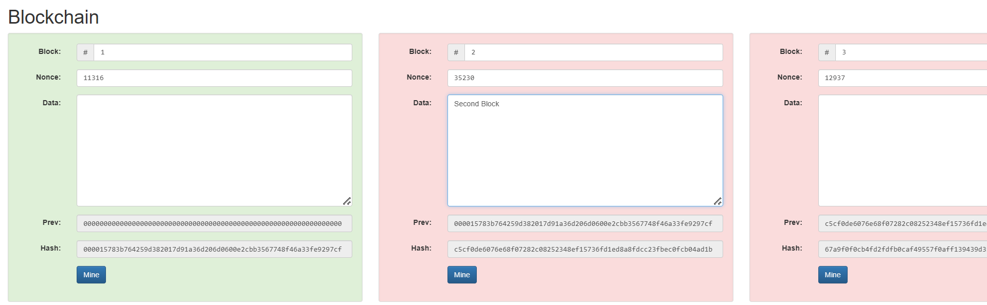

Phase: Data Inserted only in second block.
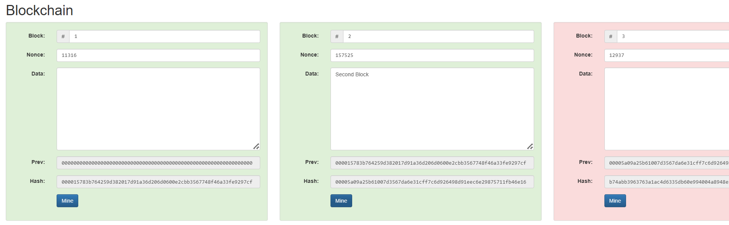

- Implementation Phase: Final Output (no error)
Applied and Action Learning

Phase: Final Output
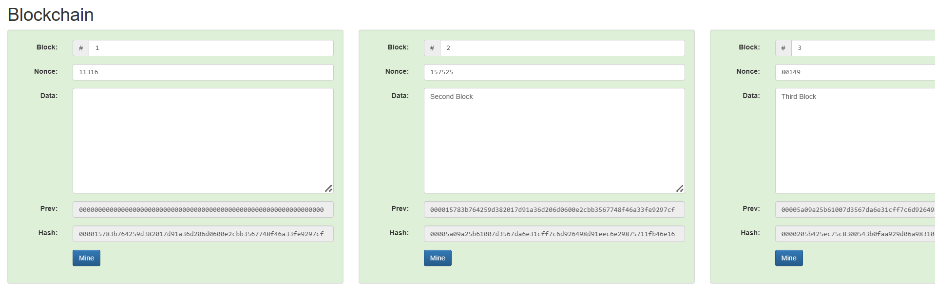

* Observations
- A block contains data, a timestamp, and a previous block hash.
- Hashing ensures integrity and immutability in blockchain.
- The hash function is deterministic but irreversible — you can get the same hash from the same data, but you can’t get the original data from the hash.
- Blockchain security is fundamentally tied to the cryptographic hash process.

ASSESMENT

Rubrics
Concept | 10
Planning and Execution/  Practical Simulation/ Programming | 10
Result and Interpretation | 10
Record of Applied and Action Learning | 10
Viva | 10
Total | 50


Signature of the Student:
Signature of the Faculty:

